** SAVEETHA SCHOOL OF ENGINEERING **

**SAVEETHA INSTITUTE OF MEDICAL AND TECHNICAL SCIENCES**

**CAPSTONE PROJECT REPORT**

**PROJECT TITLE**

A TOOL FOR VALIDATING INPUT STRING USING SLR PARSING TECHNIQUE

**TEAM MEMBERS**

192111026 KISHORE K

192124009, J. RHEA REBECCA

192125001 R AISHWARYA

**REPORT SUBMITTED BY**

192125001,R Aishwarya

**COURSE CODE / NAME**

CSA1449 / COMPILER DESIGN FOR LOW LEVEL LANGUAGE

SLOT A

**DATE OF SUBMISSION**

26.02.2024

**ABSTRACT**

By utilizing the well-known and accurate SLR parsing method, SLR-Validate transforms input string validation. Its user-friendly interface fits in perfectly with current workflows, freeing developers to concentrate on creating reliable software solutions. The key to SLR-Validate efficacy is its capacity to handle a wide range of grammatical structures seen in input strings. It also quickly detects faults and offers comprehensive feedback for successful debugging. With the help of this extensible tool, developers may ensure flexibility and adaptability by customizing validation criteria to fit project needs. Because of its simplified design, SLR-Validate speeds up the software development cycle and encourages agility and iteration in software engineering methods. Through improved data security and integrity, it establishes new benchmarks for validation techniques in a variety of applications. SLR-Validate offers simplicity, speed, and reliability in input string validation, thus representing a paradigm change in the field. Being a vital tool in contemporary software development, it influences validation paradigms going forward and gives programmers the ability to build safe and robust software systems. Encourages agility and iteration in software engineering methods. Strengthening data integrity and system security across a wide range of applications, SLR-Validate becomes a vital tool in the toolbox of contemporary software engineers, with the potential to influence software validation paradigms in the future.

**INTRODUCTION**

System security and dependability are based on the careful validation of input strings, which is essential in the ever-changing world of software development. This proposal lays out a thorough project that uses the advanced SLR parsing technology to provide a customized tool for input string validation. Fundamentally, the main goal of the project is to meet the urgent need for a reliable, dependable, and strong input string validation solution in the software development community. Through the use of SLR parsing, the suggested tool aims to provide developers with a more efficient means of examining input strings in comparison to pre-established grammatical structures. The project's goal is to improve the accuracy and efficiency of input validation activities that are woven into the complex processes of software development workflows.

This initiative's methodological trajectory develops throughout a number of carefully thought-out stages. The project starts with a detailed examination of the theoretical foundations and real-world uses of SLR parsing and then dives further into comprehending its subtleties within the context of input string validation. Armed with research-derived insights, the tool will next be painstakingly designed and put into use, using state-of-the-art algorithms and data structures that have been precisely calibrated to speed up parsing and validation processes. This project is significant because it has the potential to change the software development industry by establishing new standards for input string validation techniques. The project's goal is to strengthen the robustness and integrity of input data handling procedures by providing developers with an easy, flexible tool based on SLR parsing concepts. Additionally, the tool that is being considered has the capacity to enhance productivity by optimizing development processes, which will reduce the likelihood of mistakes and vulnerabilities that are inherent in software systems.

In conclusion, this project stands out as a shining example of software development innovation, ready to transform input string validation procedures by creating a customized tool based on the SLR parsing method. With careful attention to the project's goals, approach, and importance, this proposal establishes a strong framework for the development of a novel solution intended to improve the dependability and security of software systems.

Steps for constructing the SLR parsing table :

1. Writing augmented grammar
2. LR(0) collection of items to be found
3. Find FOLLOW of LHS of production
4. Defining 2 functions:goto[list of terminals] and action[list of non-terminals] in the parsing table

EXAMPLE – Construct LR parsing table for the given context-free grammar

S–>AA   
 A–>aA|b

Solution:

STEP1 – Find augmented grammar  
The augmented grammar of the given grammar is:-

S’–>.S [0th production]   
 S–>.AA [1st production]   
 A–>.aA [2nd production]   
 A–>.b [3rd production]

STEP2 – Find LR(0) collection of items  
Below is the figure showing the LR(0) collection of items. We will understand everything one by one.

The terminals of this grammar are {a,b}.  
The non-terminals of this grammar are {S,A}

RULE –   
If any non-terminal has ‘ . ‘ preceding it, we have to write all its production and add ‘ . ‘ preceding each of its production.

RULE –   
from each state to the next state, the ‘ . ‘ shifts to one place to the right.

* In the figure, I0 consists of augmented grammar.
* Io goes to I1 when ‘ . ‘ of 0th production is shifted towards the right of S(S’->S.). this state is the accepted state. S is seen by the compiler.
* Io goes to I2 when ‘ . ‘ of 1st production is shifted towards right (S->A.A) . A is seen by the compiler
* I0 goes to I3 when ‘ . ‘ of the 2nd production is shifted towards right (A->a.A) . a is seen by the compiler.
* I0 goes to I4 when ‘ . ‘ of the 3rd production is shifted towards right (A->b.) . b is seen by the compiler.
* I2 goes to I5 when ‘ . ‘ of 1st production is shifted towards right (S->AA.) . A is seen by the compiler
* I2 goes to I4 when ‘ . ‘ of 3rd production is shifted towards right (A->b.) . b is seen by the compiler.
* I2 goes to I3 when ‘ . ‘ of the 2nd production is shifted towards right (A->a.A) . a is seen by the compiler.
* I3 goes to I4 when ‘ . ‘ of the 3rd production is shifted towards right (A->b.) . b is seen by the compiler.
* I3 goes to I6 when ‘ . ‘ of 2nd production is shifted towards the right (A->aA.) . A is seen by the compiler
* I3 goes to I3 when ‘ . ‘ of the 2nd production is shifted towards right (A->a.A) . a is seen by the compiler.

STEP3 –   
Find FOLLOW of LHS of production

FOLLOW(S)=$  
FOLLOW(A)=a,b,$

To find the FOLLOW of non-terminals, please read  [follow set in syntax analysis.](https://www.geeksforgeeks.org/follow-set-in-syntax-analysis/)

STEP 4-   
Defining 2 functions:goto[list of non-terminals] and action[list of terminals] in the parsing table. Below is the SLR parsing table.

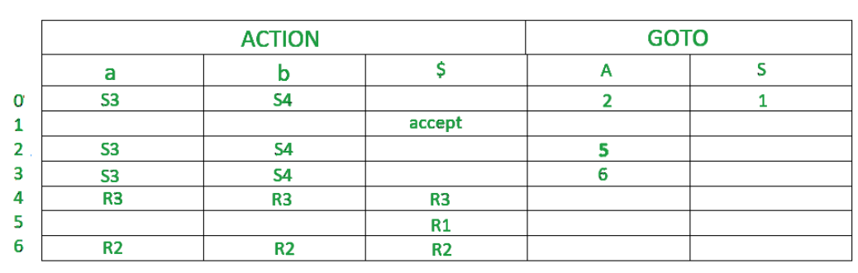

* $ is by default a nonterminal that takes accepting state.
* 0,1,2,3,4,5,6 denotes I0,I1,I2,I3,I4,I5,I6
* I0 gives A in I2, so 2 is added to the A column and 0 rows.
* I0 gives S in I1,so 1 is added to the S column and 1 row.
* similarly 5 is written in A column and 2 row, 6 is written in A column and 3 row.
* I0 gives a in I3 .so S3(shift 3) is added to a column and 0 row.
* I0 gives b in I4 .so S4(shift 4) is added to the b column and 0 row.
* Similarly, S3(shift 3) is added on a column and 2,3 row ,S4(shift 4) is added on b column and 2,3 rows.
* I4 is reduced state as ‘ . ‘ is at the end. I4 is the 3rd production of grammar(A–>.b).LHS of this production is A. FOLLOW(A)=a,b,$ . write r3(reduced 3) in the columns of a,b,$ and 4th row
* I5 is reduced state as ‘ . ‘ is at the end. I5 is the 1st production of grammar(S–>.AA). LHS of this production is S.  
  FOLLOW(S)=$ . write r1(reduced 1) in the column of $ and 5th row
* I6 is a reduced state as ‘ . ‘ is at the end. I6 is the 2nd production of grammar( A–>.aA). The LHS of this production is A.  
  FOLLOW(A)=a,b,$ . write r2(reduced 2) in the columns of a,b,$ and 6th row

**LITERATURE REVIEW**

A review of existing literature related to tools for validating input strings using SLR parsing technique reveals a limited body of work in comparison to other areas of tool for SLR parser. While much attention has been given to the development of GUIs for linguistic tools, the specific application of SLR parsing techniques for input string validation has received less emphasis. One significant contribution in this direction is the work by [(Taylor 1983)](https://paperpile.com/c/VgKnP1/3ChW) , where the authors explore the integration of SLR parsing techniques into a tool for validating input strings. The study emphasizes [(*Compilers: Principles, Techniques and Tools (for VTU)* 2007)](https://paperpile.com/c/VgKnP1/vASP) the importance of incorporating SLR parsing, a powerful parsing technique, to enhance the efficiency and accuracy of input validation processes. The authors discuss how SLR parsing can contribute to identifying syntactic errors in input strings and ensuring adherence to a given grammar. However, there is a notable gap in the literature concerning the user-centered design principles specifically tailored for tools focused on input string validation using SLR parsing[(Esl, n.d.)](https://paperpile.com/c/VgKnP1/2E0N). Unlike the extensive research on tools for SLR parser, few studies delve into the user experience aspects of tools employing SLR parsing for input validation.

Moreover, there is an opportunity for further investigation into the customization options and flexibility provided by SLR parsing-based validation tools. Research could explore how users can define and modify grammars, error messages, and validation rules to suit their specific requirements. The existing literature also falls short in addressing accessibility features within tools using SLR parsing for input validation. Considering the broader emphasis on accessibility in GUI development for linguistic tools[(Lorho 1984)](https://paperpile.com/c/VgKnP1/Tkw6), future research could explore ways to make SLR-based validation tools more inclusive for users with disabilities. In conclusion, while there is a foundation in the literature for incorporating SLR parsing into tools for validating input strings, there is a need for more comprehensive research that addresses user-centred design, customization options, and accessibility features in the context of SLR[(Grune and Jacobs 2007)](https://paperpile.com/c/VgKnP1/Nx1O) parsing techniques for input validation. Continued research in this area will contribute to the development of effective and user-friendly tools for syntactic analysis and input validation.

**RESEARCH PLAN**

The project "A Tool for Validating Input String Using SLR Parsing Technique" will be carried out in accordance with a carefully thought-out research strategy that includes a number of different elements. To get an understanding of the theoretical underpinnings and real-world applications of SLR parsing in input string validation, extensive literature research will be carried out first. This stage seeks to discover the most advanced methods and procedures in the subject and to compile insights from previous study. After reviewing the literature, several real-world experiments will be conducted to test how well SLR parsing performs while dealing with various input conditions. This entails examining current input string validation tools and methods to find weaknesses and areas for development. Working together with domain experts will be crucial to gaining knowledge and improving the approach in light of real-world issues.

Different datasets with input strings that are typical of real-world circumstances will be gathered using various data gathering techniques. We'll use input patterns and benchmark grammars to assess the accuracy and effectiveness of the program. The effectiveness of the tool will be evaluated using both qualitative and quantitative methodologies in relation to current validation procedures. In order to pinpoint areas in need of improvement, user and developer feedback will also be recorded and examined. Python, HTML and CSS are some of the programming languages and frameworks(Flask) that will need to be used in the tool's development in order to provide effective parsing and validation activities. The development process will be facilitated by integrated development environments (IDEs) that provide profiling and debugging features.Devices with their own unique set of requirements and allocations of system resources are referred to as "hardware configurations." These are the bare bones system specs needed to build this model CPU: processor Intel Core i3, 4GB of RAM, and a 500 GB hard drive.The requirements for a software programme to run on a certain system are outlined in the corresponding set of specifications. This model requires at least Windows 7/8/10, Python 3 (or later), and the integrated development environments (IDEs) PyCharm and Google Collab. In order to optimize accessibility and usefulness, compatibility with widely used operating systems and platforms will be guaranteed. Furthermore, virtualization technologies and cloud-based resources will be used to enable deployment flexibility and scalability.

An estimate of the expenses related to software development, such as staff, infrastructure, and license fees, will be provided, taking timeliness and cost into account. Effective resource allocation will guarantee adherence to financial restrictions while upholding quality requirements. A comprehensive calendar that outlines significant checkpoints and deliverables will be created, taking into account things like testing intervals, deployment dates, and iterations in the development process. In order to minimize risks and guarantee the project's timely completion, progress will be regularly monitored in relation to the predetermined time frame, and changes will be made as needed. To sum up, the study plan for "A Tool for Validating Input String Using SLR Parsing Technique'' takes a thorough approach that takes into account cost and timetable concerns, software and hardware requirements, research methodology, and data gathering techniques. The project's goal is to provide a reliable and effective solution that meets the urgent demand for improved input string validation methods in software development processes by following this strategy.

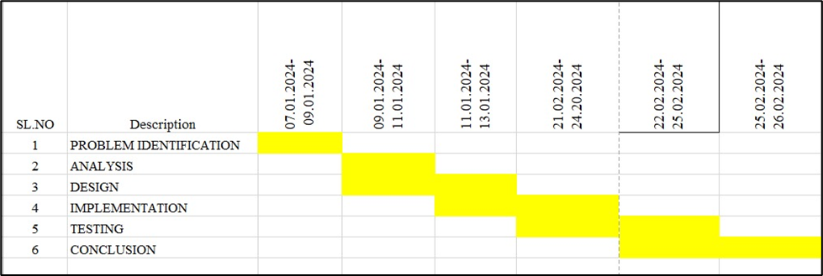

Fig. 1 Timeline chart

Day 1: Project Initiation and planning (1 day)

· Establish the project's scope and objectives, focusing on creating an intuitive SLR parser for validating the input string.

· Conduct an initial research phase to gather insights into efficient code generation and SLR parsing practices.

· Identify key stakeholders and establish effective communication channels.

· Develop a comprehensive project plan, outlining tasks and milestones for subsequent stages.

Day 2: Requirement Analysis and Design (2 days)

· Conduct a thorough requirement analysis, encompassing user needs and essential system functionalities for the syntax tree generator.

· Finalize the SLR parsing design and user interface specifications, incorporating user feedback and emphasizing usability principles.

· Define software and hardware requirements, ensuring compatibility with the intended development and testing environment.

Day 3: Development and implementation (3 days)

· Begin coding the SLR parser according to the finalized design.

· Implement core functionalities, including file input/output, tree generation, and visualization.

· Ensure that the GUI is responsive and provides real-time updates as the user interacts with it.

· Integrate the SLR parsing table into the GUI.

Day 4: GUI design and prototyping (5 days)

· Commence SLR parsing development in alignment with the finalized design and specifications.

· Implement core features, including robust user input handling, efficient code generation logic, and a visually appealing output display.

· Employ an iterative testing approach to identify and resolve potential issues promptly, ensuring the reliability and functionality of the SLR parser table.

Day 5: Documentation, Deployment, and Feedback (1 day)

· Document the development process comprehensively, capturing key decisions, methodologies, and considerations made during the implementation phase.

· Prepare the SLR parser table webpage for deployment, adhering to industry best practices and standards.

· Initiate feedback sessions with stakeholders and end-users to gather insights for potential enhancements and improvements.

Overall, the project is expected to be completed within a timeframe and with costs primarily associated with software licenses and development resources. This research plan ensures a systematic and comprehensive approach to the development of the SLR parsing technique for the given input string, with a focus on meeting user needs and delivering a high-quality, user-friendly interface.

Programming Language:

| Skeleton Language | HTML |
| --- | --- |
| Design | CSS |
| Back-end | Python |
| Frame work | Flask |

Environment:

| Front-end | Sublime text editor |
| --- | --- |
| Back-end | IDLE |

**METHODOLOGY**

The process for creating "A Tool for Validating Input String Using SLR Parsing Technique" entails a number of crucial phases that are meant to collect pertinent information, configure the environment for development, describe the algorithm with examples, and write the code efficiently.

The first step in the technique is to carry out in-depth research to collect pertinent data and information that will guide the project. Reviewing previous studies, research articles, and documentation on SLR parsing strategies, input string validation procedures, and pertinent programming languages and frameworks are all part of this process. The next stage is to set up the development environment after the research phase. This involves using frameworks(Flask) and computer languages like Python, HTML and CSS that are suitable for SLR parsing and input string validation. We'll select integrated development environments (IDEs) to make the processes of testing, debugging, and coding easier.

{FLASK -pip install flask}

Using examples to demonstrate the SLR parsing algorithm forms the basis of the technique. This entails dissecting SLR parsing fundamentals, such as shift-reduce and reduce-reduce conflicts, parsing tables, LR(0) items, and parse tree construction. The step-by-step procedure for parsing input strings utilizing SLR parsing techniques will be demonstrated with examples. Moreover, the methodology's central focus will be the execution of the SLR parsing algorithm. The chosen programming language will be used to create implementations and code snippets that show how the method works in real-world scenarios. Determining data structures, parsing tables, and methods for processing input text and building parse trees will all be necessary for this. The focus throughout the implementation phase will be on making the code as efficient and scalable as possible. To confirm the accuracy and resilience of the implementation across a range of input situations and edge cases, testing protocols will be developed.

Lastly, extensive descriptions of the method, code structure, use guidelines, and examples will be included in the documentation. Developers and users who want to learn how to utilize the tool for input string validation using SLR parsing techniques can refer to this documentation as a reference. To put it briefly, the process used to create "A Tool for Validating Input String Using SLR Parsing Technique" includes setting up the environment, explaining the algorithm and providing examples, implementing the code, testing, and documenting the results. The project hopes to provide a dependable and efficient tool for input string validation in software development processes by adhering to this methodical methodology.

Steps for run the Server:

1. Install Flask Module using the following command in the Terminal -“pip install flask”-.
2. Create your project folder with the structure:-

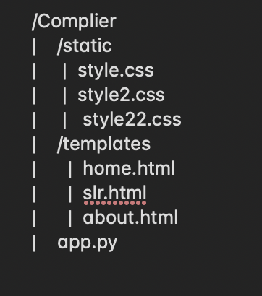

1. Change the Directory to the project folder using cd command in the terminal
2. Run the Server by executing the python code.

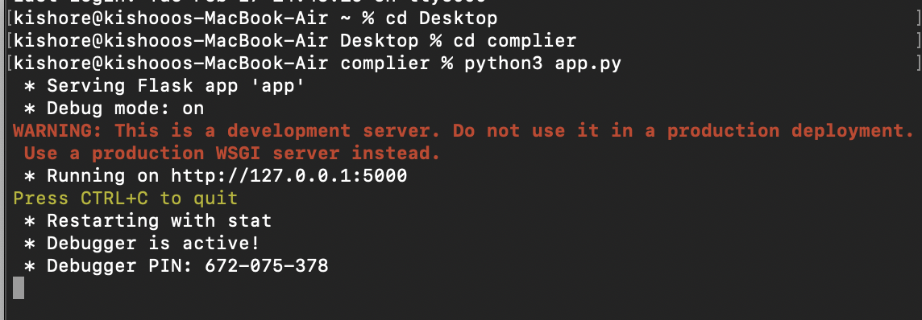

**RESULT**

The result of the title A Tool For Validating Input String Using SLR Parsing Technique Augmented Grammar, Calculated closure I0, States Generated, Result of GOTO computation, SLR(1) Parsing Table.

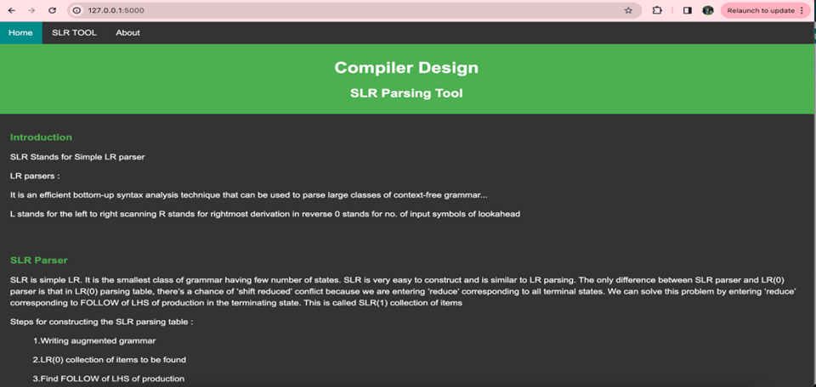

Fig.2 Home Page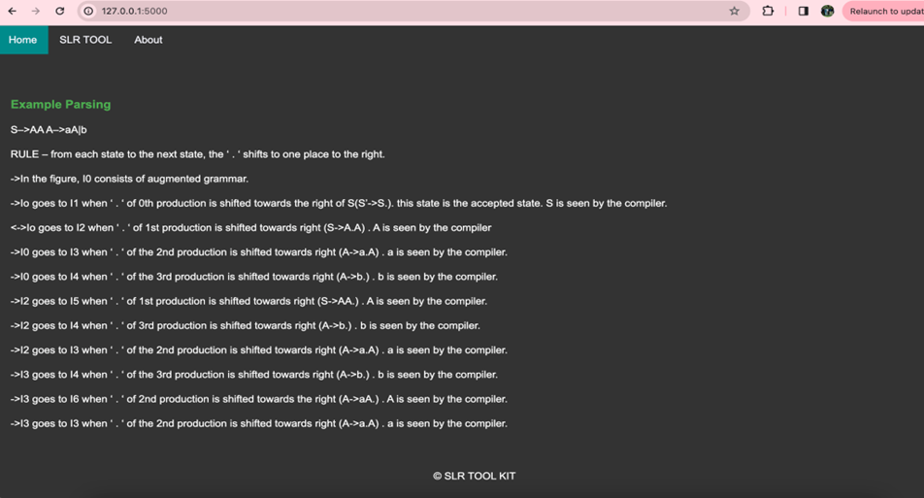

Fig. 3 Home Page 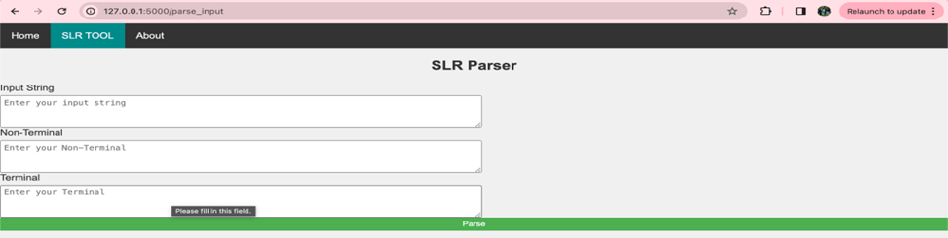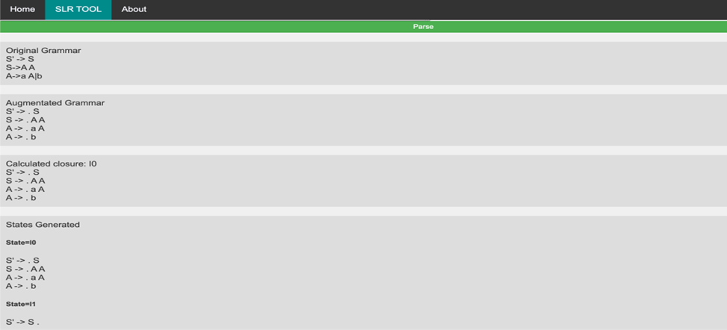



Fig. 4 Tool Page input section

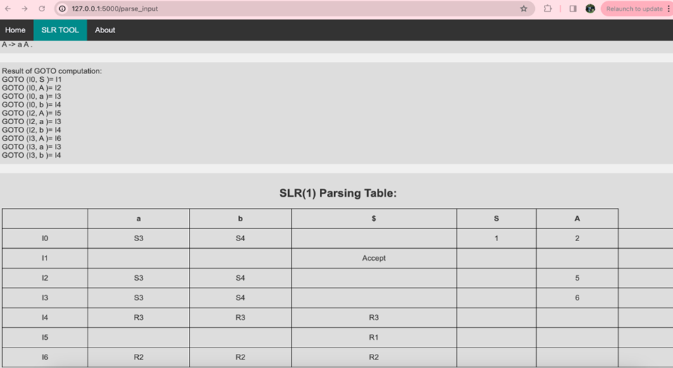

Fig. 5 Tool Page output section

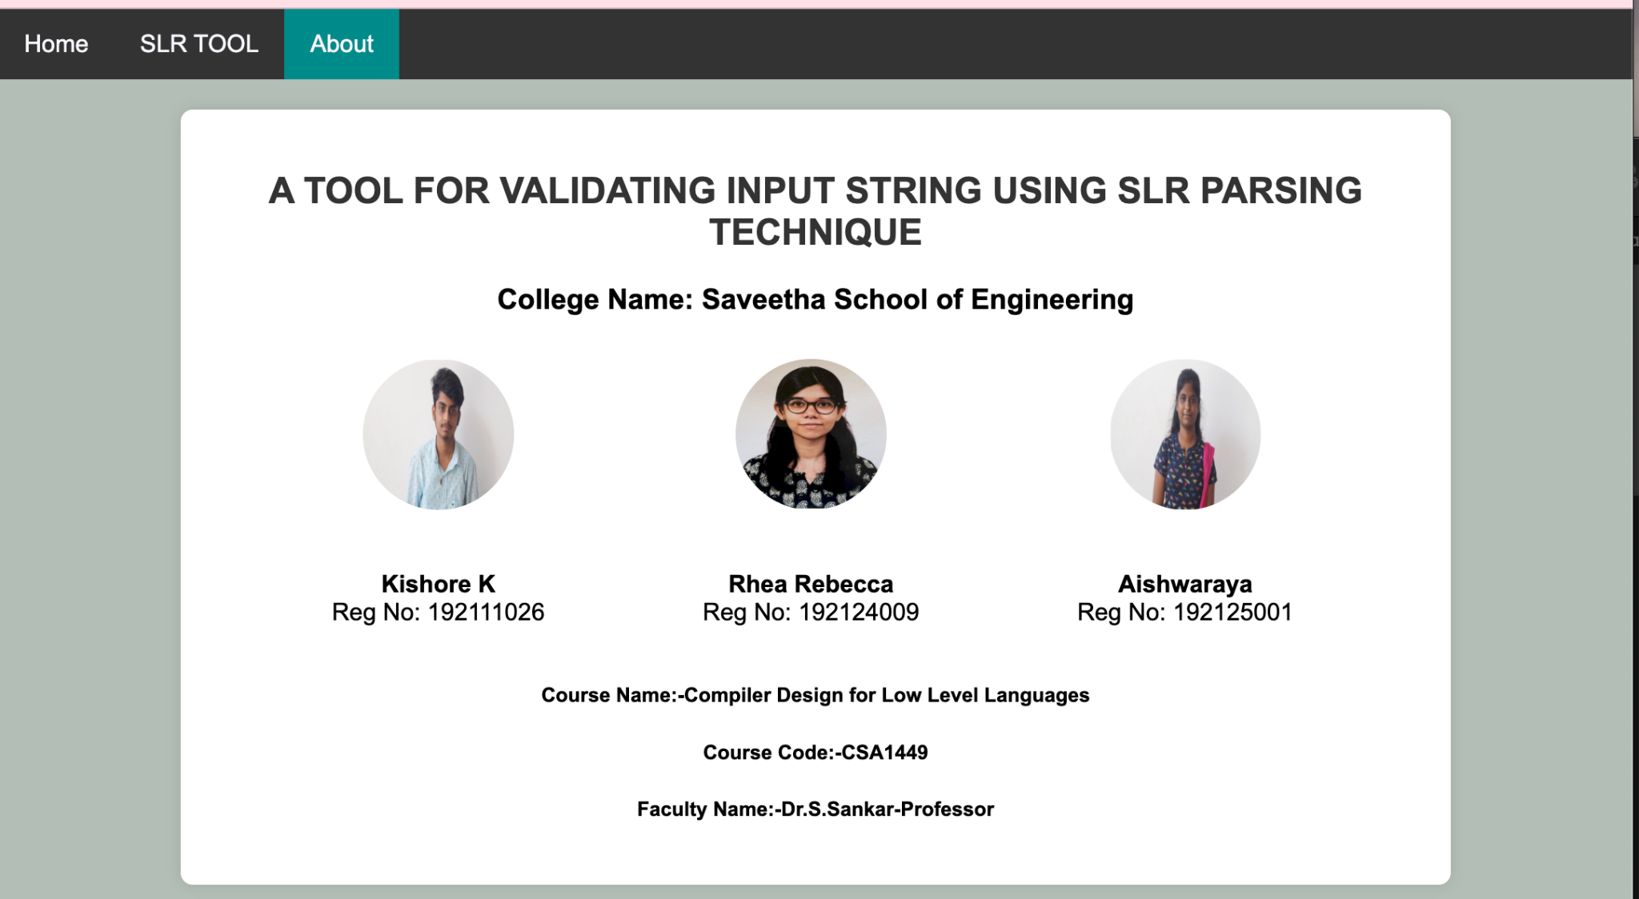

Fig. 6 About Page

**CONCLUSION**

To sum up, a significant development in computational linguistics has been made with the development of a tool for verifying input strings using the SLR parsing approach. By utilizing the speed and precision of SLR parsing, this application provides a simple and user-friendly input validation platform. Strong mistake detection and enhanced input string processing in accordance with certain grammatical rules are two of its advantages. However, there could be issues with the tool's scalability when dealing with huge or complicated input strings, and there might be restrictions on what grammatical structures it can handle.

Future improvements may concentrate on improving the SLR parsing algorithm, adding more complex error handling methods, and enhancing the tool's functionality for a wider range of language settings in order to overcome these difficulties. Furthermore, the tool might be enhanced with functionalities like collaborative validation procedures, interaction with other language resources, and interactive feedback mechanisms. In summary, even though the tool is a big step forward for input string validation utilizing SLR parsing, ongoing innovation and improvement are necessary to meet the changing needs and complexity of linguistic analysis.

**References**

[*Compilers: Principles, Techniques and Tools (for VTU)*. 2007. Pearson Education India.](http://paperpile.com/b/VgKnP1/vASP)

[Esl, Itl. n.d. *Principles of Compiler Design:* Pearson Education India](http://paperpile.com/b/VgKnP1/2E0N)

[.](http://paperpile.com/b/VgKnP1/2E0N)

[Grune, Dick, and Ceriel J. H. Jacobs. 2007. *Parsing Techniques: A Practical Guide*. Springer Science & Business Media.](http://paperpile.com/b/VgKnP1/Nx1O)

[Lorho, B. 1984. *Methods and Tools for Compiler Construction: An Advanced Course*. CUP Archive.](http://paperpile.com/b/VgKnP1/Tkw6)

[Taylor,](http://paperpile.com/b/VgKnP1/3ChW)

[Jeffrey Lawrence. 1983. *An SLR (1) Parser Generator*.](http://paperpile.com/b/VgKnP1/3ChW)

**APPENDIX I**

Home.html

<!DOCTYPE html>

<html lang="en">

<head>

<meta charset="UTF-8">

<meta name="viewport" content="width=device-width, initial-scale=1.0">

<title>SLR Parsing Tool</title>

<link rel="stylesheet" href="{{ url_for('static', filename='style.css') }}">

<link rel="icon" type="image/x-icon" href="https://cdn-icons-png.flaticon.com/512/8093/8093308.png">

</head>

<body class="dark">

<ul>

<li><a class="active" href="{{url_for('home')}}">Home</a></li>

<li><a href="{{url_for('parse_input')}}">SLR TOOL</a></li>

<li><a href="{{url_for('about')}}">About</a></li>

</ul>

<header>

<h1>Capstone Project</h1>

<h2>A TOOL FOR VALIDATING INPUT STRING USING SLR PARSING TECHNIQUE</h2>

</header>

<section id="introduction">

<h3>Introduction</h3>

<p>SLR Stands for Simple LR parser</p>

<p>LR parsers :</p>

<p>It is an efficient bottom-up syntax analysis technique that can be used to parse large classes of context-free grammar...</p>

<p>L stands for the left to right scanning

R stands for rightmost derivation in reverse

0 stands for no. of input symbols of lookahead</p>

</section>

<section id="slr-parser">

<h3>SLR Parser</h3>

<p>SLR is simple LR. It is the smallest class of grammar having few number of states. SLR is very easy to construct and is similar to LR parsing. The only difference between SLR parser and LR(0) parser is that in LR(0) parsing table, there’s a chance of ‘shift reduced’ conflict because we are entering ‘reduce’ corresponding to all terminal states. We can solve this problem by entering ‘reduce’ corresponding to FOLLOW of LHS of production in the terminating state. This is called SLR(1) collection of items</p>

<p>Steps for constructing the SLR parsing table :</p>

<ol>

<p> 1.Writing augmented grammar</p>

<p> 2.LR(0) collection of items to be found</p>

<p> 3.Find FOLLOW of LHS of production</p>

<p> 4.Defining 2 functions: goto[list of terminals] and action[list of non-terminals] in the parsing table.</p>

</ol>

<p>RULE – If any non-terminal has ‘ . ‘ preceding it, we have to write all its production and add ‘ . ‘ preceding each of its production.</p>

<p>RULE – From each state to the next state, the ‘ . ‘ shifts to one place to the right.</p>

</section>

<section id="parsing-example">

<h3>Example Parsing</h3>

<p>

S–>AA

A–>aA|b

</p>

<p>RULE – from each state to the next state, the ‘ . ‘ shifts to one place to the right.</p>

<p>->In the figure, I0 consists of augmented grammar.</p>

<p>->Io goes to I1 when ‘ . ‘ of 0th production is shifted towards the right of S(S’->S.). this state is the accepted state. S is seen by the compiler.</p>

<p><->Io goes to I2 when ‘ . ‘ of 1st production is shifted towards right (S->A.A) . A is seen by the compiler</p>

<p>->I0 goes to I3 when ‘ . ‘ of the 2nd production is shifted towards right (A->a.A) . a is seen by the compiler.</p>

<p>->I0 goes to I4 when ‘ . ‘ of the 3rd production is shifted towards right (A->b.) . b is seen by the compiler.</p>

<p>->I2 goes to I5 when ‘ . ‘ of 1st production is shifted towards right (S->AA.) . A is seen by the compiler.</p>

<p>->I2 goes to I4 when ‘ . ‘ of 3rd production is shifted towards right (A->b.) . b is seen by the compiler.</p>

<p>->I2 goes to I3 when ‘ . ‘ of the 2nd production is shifted towards right (A->a.A) . a is seen by the compiler.</p>

<p>->I3 goes to I4 when ‘ . ‘ of the 3rd production is shifted towards right (A->b.) . b is seen by the compiler.</p>

<p>->I3 goes to I6 when ‘ . ‘ of 2nd production is shifted towards the right (A->aA.) . A is seen by the compiler.</p>

<p>->I3 goes to I3 when ‘ . ‘ of the 2nd production is shifted towards right (A->a.A) . a is seen by the compiler.</p>

</section>

<footer>

<p>&copy; SLR TOOL KIT</p>

</footer>

</body>

</html>

Slr.html

<!DOCTYPE html>

<html lang="en">

<head>

<meta charset="UTF-8">

<meta name="viewport" content="width=device-width, initial-scale=1.0">

<link rel="stylesheet" href="{{ url_for('static', filename='style2.css') }}">

<link rel="icon" type="image/x-icon" href="https://cdn-icons-png.flaticon.com/512/8093/8093308.png">

<title>SLR Parser</title>

</head>

<body>

<ul>

<li><a href="{{url_for('home')}}">Home</a></li>

<li><a class="active" href="{{url_for('parse_input')}}">SLR TOOL</a></li>

<li><a href="{{url_for('about')}}">About</a></li>

</ul>

<h2>SLR Parser</h2>

<form action="{{ url_for('parse_input') }}" method="post">

<label for="inputString">Input String</label>

<textarea id="inputString" name="inputString" placeholder="Enter your input string" required></textarea>

<label for="nonterminal">Non-Terminal</label>

<textarea id="nonterminal" name="nonterminal" placeholder="Enter your Non-Terminal" required></textarea>

<label for="terminal">Terminal</label>

<textarea id="terminal" name="terminal" placeholder="Enter your Terminal" required></textarea>

<button type="submit">Parse</button>

</form>

{% if org %}

<div id="result">

Original Grammar

<br>

{% for i in org %}

{{ i }}

<br />

{% endfor %}

</div>

{% endif %}

{% if aug %}

<div id="result">

Augmentated Grammar

<br>

{% for i in aug %}

{{ i[0] }} -&gt; {{' '.join(i[1]) }}

<br>

{% endfor %}

</div>

{% endif %}

{% if I0 %}

<div id="result">

Calculated closure: I0

<br>

{% for i in I0 %}

{{ i[0] }} -&gt; {{' '.join(i[1]) }}

<br>

{% endfor %}

</div>

{% endif %}

{% if state %}

<div id="result">

States Generated

<br>

{% for i in state %}

<h5>State=I{{i}}</h5>

{% for j in state[i] %}

{{ j[0] }} -&gt; {{' '.join(j[1]) }}

<br>

{% endfor %}

{% endfor %}

</div>

{% endif %}

{% if statemap %}

<div id="result">

Result of GOTO computation:

<br>

{% for i in statemap %}

GOTO (I{{i[0]}}, {{i[1]}} )= I{{statemap[i]}}

<br>

{% endfor %}

</div>

{% endif %}

{% if table1 %}

{% if col2 %}

<div id="result">

<h2>SLR(1) Parsing Table:</h2>

<table>

<thead>

<tr>

<th></th>

{% for j in col2 %}

<th>{{ j }}</th>

{% endfor %}

</tr>

</thead>

<tbody>

{% for i in range(table1|length) %}

<tr>

<td>I{{ i }}</td>

{% for entry in table1[i] %}

<td>{{ entry }}</td>

{% endfor %}

</tr>

{% endfor %}

{% endif %}

{% endif %}

</tbody>

</table>

</tbody>

</body>

</html>

About.html

<!DOCTYPE html>

<html lang="en">

<head>

<meta charset="UTF-8">

<meta name="viewport" content="width=device-width, initial-scale=1.0">

<link rel="stylesheet" href="{{ url_for('static', filename='style22.css') }}">

<link rel="icon" type="image/x-icon" href="https://cdn-icons-png.flaticon.com/512/8093/8093308.png">

<title>SLR Parser</title>

</head>

<body>

<ul>

<li><a href="{{url_for('home')}}">Home</a></li>

<li><a href="{{url_for('parse_input')}}">SLR TOOL</a></li>

<li><a class="active" href="{{url_for('about')}}">About</a></li>

</ul>

<section>

<h2>A TOOL FOR VALIDATING INPUT STRING USING SLR PARSING TECHNIQUE</h2>

<h3>College Name: Saveetha School of Engineering</h3>

<div class="team-member">

<img src="{{ url_for('static', filename='kishore.jpg') }}" width="160" height="160" alt="Kishore K">

<p><strong>Kishore K</strong><br>Reg No: 192111026</p>

</div>

<div class="team-member">

<img src="{{ url_for('static', filename='rii.jpg') }}" alt="Rhea Rebecca" width="160" height="160">

<p><strong>Rhea Rebecca</strong><br>Reg No: 192124009</p>

</div>

<div class="team-member">

<img src="{{ url_for('static', filename='aisu.jpg') }}" alt="Aishwaraya" width="160" height="160">

<p><strong>Aishwaraya</strong><br>Reg No: 192125001</p>

</div>

<div class="faculty">

<h5>Course Name:-Compiler Design for Low Level Languages</h5>

<h5>Course Code:-CSA1449</h5>

<h5>Faculty Name:-Dr.S.Sankar-Professor</h5>

</div>

</section>

<footer>

&copy; A TOOL FOR VALIDATING INPUT STRING USING SLR PARSING TECHNIQUE

</footer>

</body>

</html>

app.py

from flask import Flask,render_template,request

import copy

app= Flask(__name__)

@app.route('/')

def home():

return render_template('home.html')

# perform grammar augmentation

def grammarAugmentation(rules, nonterm_userdef,

start_symbol):

# newRules stores processed output rules

newRules = []

# create unique 'symbol' to

# - represent new start symbol

newChar = start_symbol + "'"

while (newChar in nonterm_userdef):

newChar += "'"

# adding rule to bring start symbol to RHS

newRules.append([newChar,

['.', start_symbol]])

# new format => [LHS,[.RHS]],

# can't use dictionary since

# - duplicate keys can be there

for rule in rules:

# split LHS from RHS

k = rule.split("->")

lhs = k[0].strip()

rhs = k[1].strip()

# split all rule at '|'

# keep single derivation in one rule

multirhs = rhs.split('|')

for rhs1 in multirhs:

rhs1 = rhs1.strip().split()

# ADD dot pointer at start of RHS

rhs1.insert(0, '.')

newRules.append([lhs, rhs1])

return newRules

# find closure

def findClosure(input_state, dotSymbol):

global statesDict,aug1

start_symbol=aug1[0][0][0]

# closureSet stores processed output

closureSet = []

# if findClosure is called for

# - 1st time i.e. for I0,

# then LHS is received in "dotSymbol",

# add all rules starting with

# - LHS symbol to closureSet

if dotSymbol == start_symbol:

for rule in aug1[0]:

if rule[0] == dotSymbol:

closureSet.append(rule)

else:

# for any higher state than I0,

# set initial state as

# - received input_state

closureSet = input_state

# iterate till new states are

# - getting added in closureSet

prevLen = -1

while prevLen != len(closureSet):

prevLen = len(closureSet)

# "tempClosureSet" - used to eliminate

# concurrent modification error

tempClosureSet = []

# if dot pointing at new symbol,

# add corresponding rules to tempClosure

for rule in closureSet:

indexOfDot = rule[1].index('.')

if rule[1][-1] != '.':

dotPointsHere = rule[1][indexOfDot + 1]

for in_rule in aug1[0]:

if dotPointsHere == in_rule[0] and \

in_rule not in tempClosureSet:

tempClosureSet.append(in_rule)

# add new closure rules to closureSet

for rule in tempClosureSet:

if rule not in closureSet:

closureSet.append(rule)

return closureSet

def compute_GOTO(state):

global statesDict, stateCount

# find all symbols on which we need to

# make function call - GOTO

generateStatesFor = []

for rule in statesDict[state]:

# if rule is not "Handle"

if rule[1][-1] != '.':

indexOfDot = rule[1].index('.')

dotPointsHere = rule[1][indexOfDot + 1]

if dotPointsHere not in generateStatesFor:

generateStatesFor.append(dotPointsHere)

# call GOTO iteratively on all symbols pointed by dot

if len(generateStatesFor) != 0:

for symbol in generateStatesFor:

GOTO(state, symbol)

return

def GOTO(state, charNextToDot):

global statesDict, stateCount, stateMap

# newState - stores processed new state

newState = []

for rule in statesDict[state]:

indexOfDot = rule[1].index('.')

if rule[1][-1] != '.':

if rule[1][indexOfDot + 1] == \

charNextToDot:

# swapping element with dot,

# to perform shift operation

shiftedRule = copy.deepcopy(rule)

shiftedRule[1][indexOfDot] = \

shiftedRule[1][indexOfDot + 1]

shiftedRule[1][indexOfDot + 1] = '.'

newState.append(shiftedRule)

# add closure rules for newState

# call findClosure function iteratively

# - on all existing rules in newState

# addClosureRules - is used to store

# new rules temporarily,

# to prevent concurrent modification error

addClosureRules = []

for rule in newState:

indexDot = rule[1].index('.')

# check that rule is not "Handle"

if rule[1][-1] != '.':

closureRes = \

findClosure(newState, rule[1][indexDot + 1])

for rule in closureRes:

if rule not in addClosureRules \

and rule not in newState:

addClosureRules.append(rule)

# add closure result to newState

for rule in addClosureRules:

newState.append(rule)

# find if newState already present

# in Dictionary

stateExists = -1

for state_num in statesDict:

if statesDict[state_num] == newState:

stateExists = state_num

break

# stateMap is a mapping of GOTO with

# its output states

if stateExists == -1:

# if newState is not in dictionary,

# then create new state

stateCount += 1

print('statecount',stateCount)

statesDict[stateCount] = newState

print(statesDict)

stateMap[(state, charNextToDot)] = stateCount

else:

# if state repetition found,

# assign that previous state number

stateMap[(state, charNextToDot)] = stateExists

return

def generateStates(statesDict):

prev_len = -1

called_GOTO_on = []

# run loop till new states are getting added

while (len(statesDict) != prev_len):

prev_len = len(statesDict)

keys = list(statesDict.keys())

print('keys',keys)

# make compute_GOTO function call

# on all states in dictionary

for key in keys:

if key not in called_GOTO_on:

called_GOTO_on.append(key)

compute_GOTO(key)

return

# calculation of first

# epsilon is denoted by '#' (semi-colon)

# pass rule in first function

def first(rule):

global strl, nonl, \

terl, diction, firsts

# recursion base condition

# (for terminal or epsilon)

if len(rule) != 0 and (rule is not None):

if rule[0] in terl:

return rule[0]

elif rule[0] == '#':

return '#'

# condition for Non-Terminals

if len(rule) != 0:

if rule[0] in list(diction.keys()):

# fres temporary list of result

fres = []

rhs_rules = diction[rule[0]]

# call first on each rule of RHS

# fetched (& take union)

for itr in rhs_rules:

indivRes = first(itr)

if type(indivRes) is list:

for i in indivRes:

fres.append(i)

else:

fres.append(indivRes)

# if no epsilon in result

# - received return fres

if '#' not in fres:

return fres

else:

# apply epsilon

# rule => f(ABC)=f(A)-{e} U f(BC)

newList = []

fres.remove('#')

if len(rule) > 1:

ansNew = first(rule[1:])

if ansNew != None:

if type(ansNew) is list:

newList = fres + ansNew

else:

newList = fres + [ansNew]

else:

newList = fres

return newList

# if result is not already returned

# - control reaches here

# lastly if eplison still persists

# - keep it in result of first

fres.append('#')

return fres

# calculation of follow

def follow(nt):

global rules, nonterm_userdef, \

term_userdef, diction, firsts, follows

start_symbol=aug1[0][0][0]

# for start symbol return $ (recursion base case)

solset = set()

if nt == start_symbol:

# return '$'

solset.add('$')

# check all occurrences

# solset - is result of computed 'follow' so far

# For input, check in all rules

for curNT in diction:

rhs = diction[curNT]

# go for all productions of NT

for subrule in rhs:

if nt in subrule:

# call for all occurrences on

# - non-terminal in subrule

while nt in subrule:

index_nt = subrule.index(nt)

subrule = subrule[index_nt + 1:]

# empty condition - call follow on LHS

if len(subrule) != 0:

# compute first if symbols on

# - RHS of target Non-Terminal exists

res = first(subrule)

# if epsilon in result apply rule

# - (A->aBX)- follow of -

# - follow(B)=(first(X)-{ep}) U follow(A)

if '#' in res:

newList = []

res.remove('#')

ansNew = follow(curNT)

if ansNew != None:

if type(ansNew) is list:

newList = res + ansNew

else:

newList = res + [ansNew]

else:

newList = res

res = newList

else:

# when nothing in RHS, go circular

# - and take follow of LHS

# only if (NT in LHS)!=curNT

if nt != curNT:

res = follow(curNT)

# add follow result in set form

if res is not None:

if type(res) is list:

for g in res:

solset.add(g)

else:

solset.add(res)

return list(solset)

def createParseTable(statesDict, stateMap, T, NT):

global aug1, diction

# create rows and cols

rows = list(statesDict.keys())

cols = T+['$']+NT

print(rows)

print(cols)

# create empty table

Table = []

tempRow = ['']

for y in range(len(cols)):

tempRow.append('')

for x in range(len(rows)):

Table.append(copy.deepcopy(tempRow))

# make shift and GOTO entries in table

for entry in stateMap:

state = entry[0]

symbol = entry[1]

# get index

a = rows.index(state)

b = cols.index(symbol)

if symbol in NT:

Table[a][b] = Table[a][b]\

+ f"{stateMap[entry]} "

elif symbol in T:

Table[a][b] = Table[a][b]\

+ f"S{stateMap[entry]} "

# start REDUCE procedure

# number the separated rules

numbered = {}

key_count = 0

for rule in aug1[0]:

tempRule = copy.deepcopy(rule)

tempRule[1].remove('.')

numbered[key_count] = tempRule

key_count += 1

# start REDUCE procedure

# format for follow computation

addedR = f"{aug1[0][0][0]} -> " \

f"{aug1[0][0][1][1]}"

strl.insert(0, addedR)

for rule in strl:

k = rule.split("->")

# remove un-necessary spaces

k[0] = k[0].strip()

k[1] = k[1].strip()

rhs = k[1]

multirhs = rhs.split('|')

# remove un-necessary spaces

for i in range(len(multirhs)):

multirhs[i] = multirhs[i].strip()

multirhs[i] = multirhs[i].split()

diction[k[0]] = multirhs

# find 'handle' items and calculate follow.

for stateno in statesDict:

for rule in statesDict[stateno]:

if rule[1][-1] == '.':

# match the item

temp2 = copy.deepcopy(rule)

temp2[1].remove('.')

for key in numbered:

if numbered[key] == temp2:

# put Rn in those ACTION symbol columns,

# who are in the follow of

# LHS of current Item.

follow_result = follow(rule[0])

for col in follow_result:

index = cols.index(col)

if key == 0:

Table[stateno][index] = "Accept"

else:

Table[stateno][index] =\

Table[stateno][index]+f"R{key} "

coll.append(cols)

return Table

@app.route('/parse_input', methods=['POST','GET'])

def parse_input():

if request.method=="POST":

global stateCount

if(len(strl)>0 or len(terl)>0 or len(nonl)>0 or len(aug1)>0 or len(coll)>0 or len(statesDict)>0 or len(stateMap)>0 or len(diction)>0):

strl.clear()

terl.clear()

nonl.clear()

aug1.clear()

coll.clear()

statesDict.clear()

stateMap.clear()

diction.clear()

stateCount = stateCount-stateCount

result=[]

str1=""

str2=""

str3=""

string=request.form.get('inputString')

terminal=request.form.get('terminal')

nonterminal=request.form.get('nonterminal')

for i in string:

if(i=="\r"):

pass

elif(i=="\n"):

strl.append(str1)

str1=""

else:

str1+=i

strl.append(str1)

'''---------------------------'''

for i in nonterminal:

if(i==","):

nonl.append(str2)

str2=""

else:

str2+=i

nonl.append(str2)

'''---------------------------'''

for i in terminal:

if(i==","):

terl.append(str3)

str3=""

else:

str3+=i

terl.append(str3)

'''---------------------------'''

'''----------Augmentation-------'''

start=nonl[0]

aug=grammarAugmentation(strl,nonl,start)

aug1.append(aug)

'''-------calculated closure------'''

start_sym=aug[0][0]

I0=findClosure(0,start_sym)

'''-----------State Generate--------'''

#print('i0',I0)

statesDict[0] = I0

generateStates(statesDict)

#print('statedict',statesDict)

table=createParseTable(statesDict, stateMap,

terl,

nonl)

return render_template('slr.html',org=strl,aug=aug,I0=I0,state=statesDict,statemap=stateMap,table1=table,col2=coll[0])

return render_template('slr.html')

@app.route('/about')

def about():

return render_template('about.html')

statesDict = {}

stateMap = {}

diction = {}

stateCount = 0

strl=[]

terl=[]

nonl=[]

aug1=[]

coll=[]

if __name__ == '__main__':

app.run(debug=True)